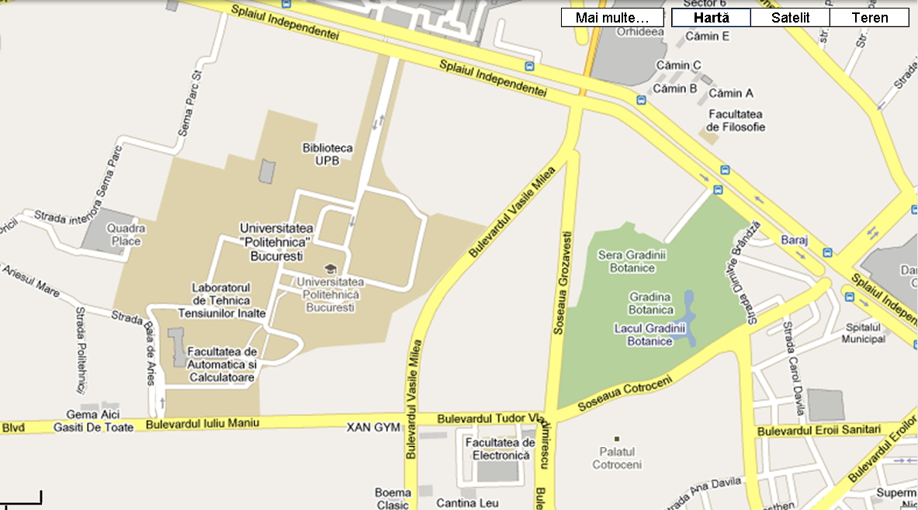
Vodafone
BN
AN
R
M
M
Metrou Politehnica
Cladire birouri, sediu Vodafone
Bus 336, 136
Trolley bus 61,62
Rectorat UPB,
Senate Room
ICMIE 2011 main entrance
International Conference of Management and Industrial Engineering - ICMIE 2011
www.icmie.ro

