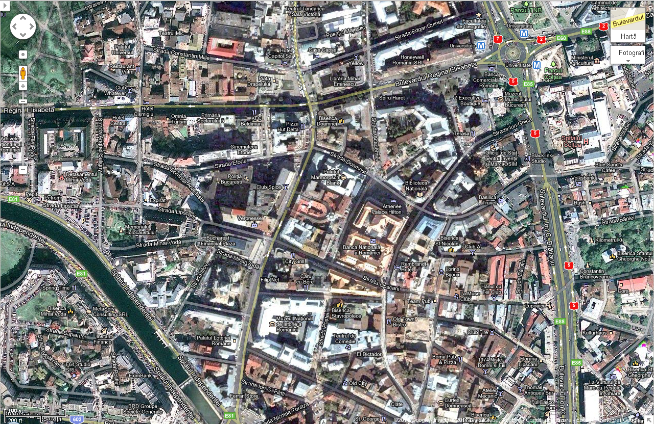
Restaurant City Grill,
Str. Lipscani Nr. 12

